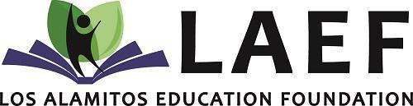

PRESS RELEASE
For Immediate Release
March 2026
Contact: Lauren DeNinno, Donor Relations & Development Manager - (562) 799-4700 x77841

LAEF’s Night Out: Community Supports Los Al Kids

(Los Alamitos, CA) – The Los Alamitos Education Foundation (LAEF) welcomed more than 250 community members to its signature fundraising event, LAEF’s Night Out: Funding Big Needs for Our Kids, held February 28 at the Seal Beach Tennis & Pickleball Center. The evening brought together parents, educators, and community leaders for a night of music, auctions, and philanthropy in support of Los Alamitos Unified School District students. The fundraising campaign has brought in over $190,000!
Guests enjoyed an entertaining performance from the band Flashpants, dancing to hits from the 80s while celebrating the shared mission of supporting Los Al kids.
“We are incredibly grateful for the community’s continued support of LAEF’s Night Out,” said Carrie Logue, LAEF Executive Director. “This event brings together people who care deeply about our students, and the funds raised help provide impactful programs and opportunities across the district.”
The evening featured a paddle raise to fund “Big Needs for Our Kids”, a Live Auction, and an Online Auction that allowed the broader community to participate. Community support was also evident through business sponsorships, with Southland Credit Union and Clean Wave Express Carwash serving as top sponsors at the $15,000 level.

Southland Credit Union, a longtime LAEF supporter, is a $1.2 billion credit union serving more than 70,000 members across Orange and Los Angeles Counties and is extremely involved in supporting local schools and community initiatives.
Clean Wave Express Carwash, located in Los Alamitos, also returned as a top sponsor. Owned by community members Brian Leibl, George Voigt, and Will Mingram, Clean Wave has strong ties to the district and continues to support programs that benefit local students and educators.
In October, LAEF donated over $154,000 to fund Innovation Grants for the current school year. These grants, requested by school staff, benefit all six elementary schools, both middle schools, Los Alamitos High School, and the Adult Transition Program.
LAEF continues to support the district through funding for student mental health and wellness, STEAM instruction, World Language programs, scholarships, enrichment opportunities, and Innovation Grants that benefit students throughout Los Alamitos Unified School District.
LAEF is the non-profit partner of Los Alamitos Unified School District. LAEF enhances educational excellence by providing after-school and summer enrichment programs to children in grades K to 12. LAEF provides significant funding for mental health/wellness and STEAM instruction, as well as igniting new programs and providing valuable resources, to impact all students. For additional information on LAEF, please call (562) 799-4700 Extension 80424 or visit www.LAEF4Kids.org.

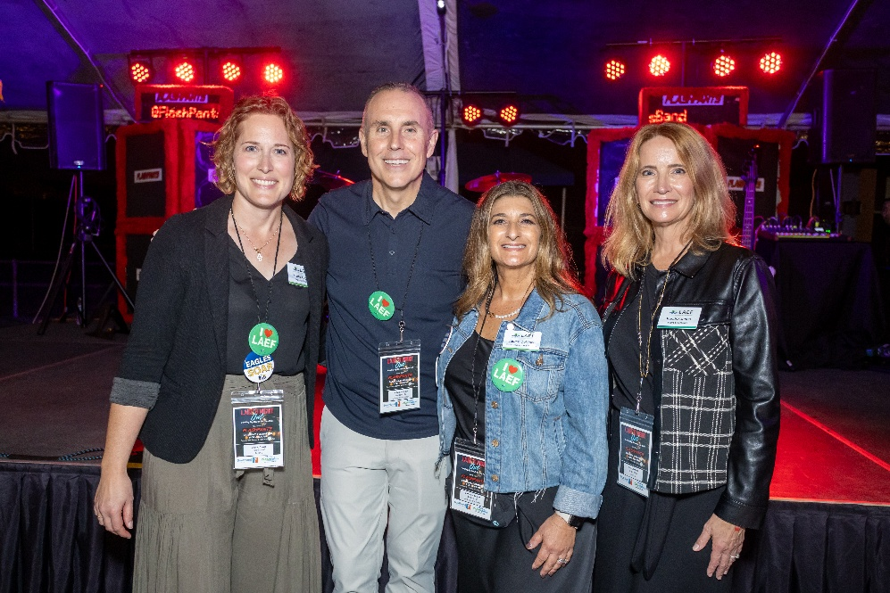
From left to right: LAEF Executive Director Carrie Logue, Los Al USD Superintendent Dr. Andrew Pulver, LAEF Donor Relations and Development Manager Lauren DeNinno, LAEF Board Chair Kendra Jones

From left to right: LAEF Board Vice Chair Matt Herrick, Los Al USD Communications and Public Information Officer Nichole Pichardo, McAuliffe Middle School Principal Eddie Courtemarche, Weaver Elementary School Principal Dr. Todd Schmidt and LAEF Immediate Past Board Chair Felicia Gonzalez
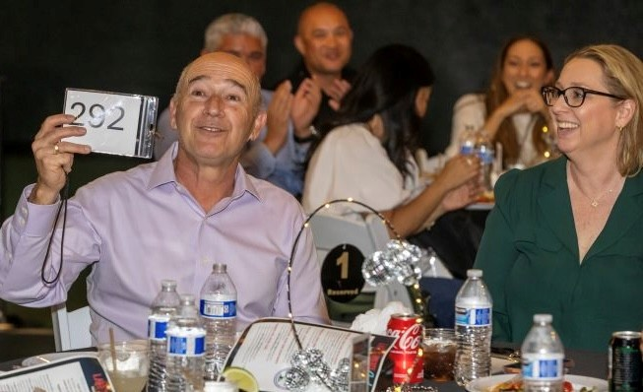
Guests raise their paddle in the Live Auction to support LAEF.

Guests of LAEF’s Night Out enjoying the performance from Flashpants

